Eyeconic - Glasses Shop Management System

Use-Case Specification: Remove Brands

Version 1.0

Revision History

|  |  |  |  |
| --- | --- | --- | --- |
| **Date** | **Version** | **Description** | **Author** |
| 05/11/2019 | 1.0 | Start creating use case | Đỗ Nguyễn Hoàng Ân |
|  |  |  |  |
|  |  |  |  |
|  |  |  |  |

Table of Contents

1. Remove Brands 4

1.1 Brief Description 4

1.2 Basic Flow 4

1.2 Exception 4

1.2.1 Remove brand 4

1.2.2 Confirming editing the brand 5

2. Special Requirements 5

3. Preconditions 5

4. Postconditions 5

5. Extension Points 5

Use-Case Specification: Remove Brands

# Remove Brands

## Brief Description

This use case defines the step of removing existing brand from the database.

Brands are removed by the admin.

## Basic Flow

The system administration selects the Brands data to remove. The administrator deletes the Brands data from the website. The system displays the updated management parameter value and logs the change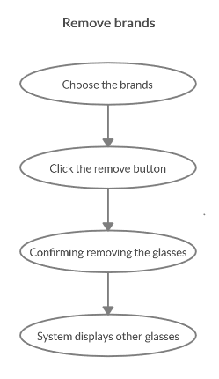

***Basic flow of Removing Brands***

Step 1: Choose the brand you want to remove

Step 2: Click remove button

A modal view shows up with content “Are you sure want to remove this item?”

and two button “Yes” and “No”

Step 3: Confirming adding the brand by clicking the “Yes” button.

Step 4: Brand are removed from database and no longer appeared on the screen.

## 1.2 Exception

### 1.2.1 Remove brand

The remove button cannot be clicked or isn’t appeared on the screen

### 1.2.2 Confirming editing the brand

The “Yes” button is clicked but the the brand are not removed.

# Special Requirements

No Special Requirements

# Preconditions

* User must already login as the administrator of the website.
* There aren’t any items in this brand

# Postconditions

All others brand can be shown like normal.

Deleted brand can not be seen on the screen or database.

# Extension Points

Administrator check the website and the system to ensure that the brands is completely removed.